**SanDisk Extreme PRO Portable SSD Up to 4TB - 1TB**

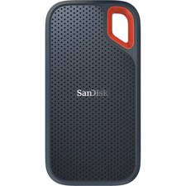

**Key Specifications:**

* **Capacity**: 1TB
* **Interface**: USB 3.2 Gen 2x2 (Type-C)
* **Sequential Read Speed**: Up to 2,000 MB/s
* **Sequential Write Speed**: Up to 2,000 MB/s

**Accessories Included**

* USB-C to USB-C cable
* USB-C to USB-A adapter

**Advanced Technology:**

* **Encryption**:  
  Includes 256-bit AES hardware encryption to protect sensitive data.
* **Compatibility**:  
  Works with Windows, macOS, and Android devices. Plug-and-play functionality with USB-C and USB-A compatibility.

**Warranty:**

* Backed by a **5-year limited warranty**, ensuring quality and support.